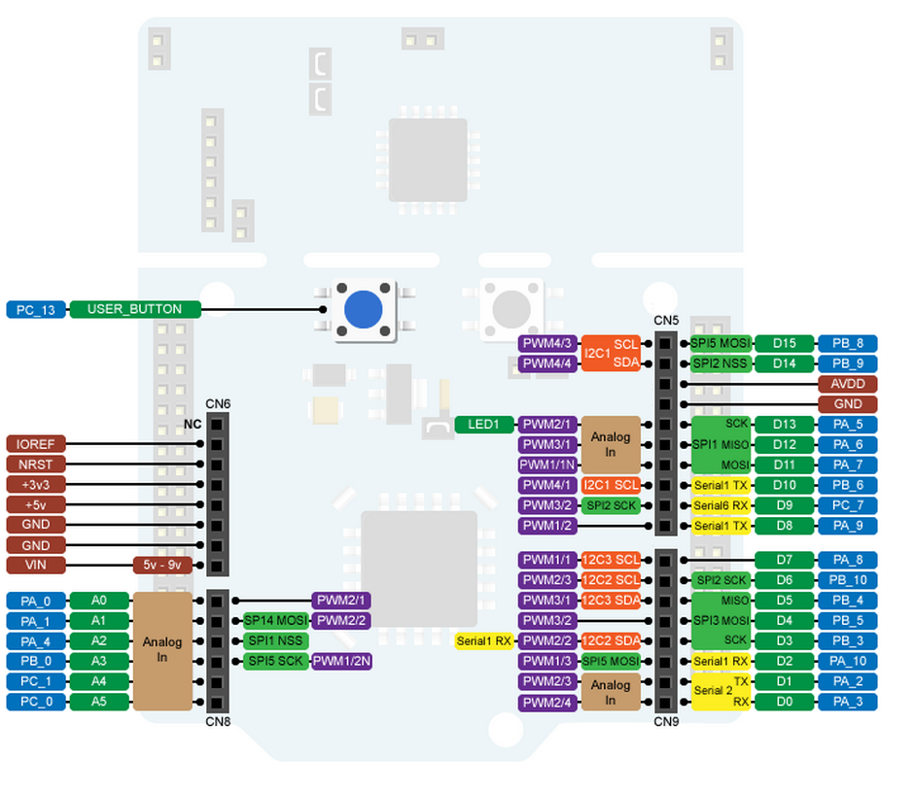

|  |  |  |
| --- | --- | --- |
| **PIN** | **Function** | **Type** |
| PA_0 | Encoder Phase A | Digital Input |
| PA_1 | Encoder Phase B | Digital Input |
| PB_0 | Current sensor | Analog Input |
| PC_0 | Target Omega | Analog Input |
| PC_13 | User Button (Start Extimation) | Digital Input |
| PA_3 | PWM control motor | Digital Output |
| PA_5 | Led State | Digital Output |